**Teach Me Bridge Classes**

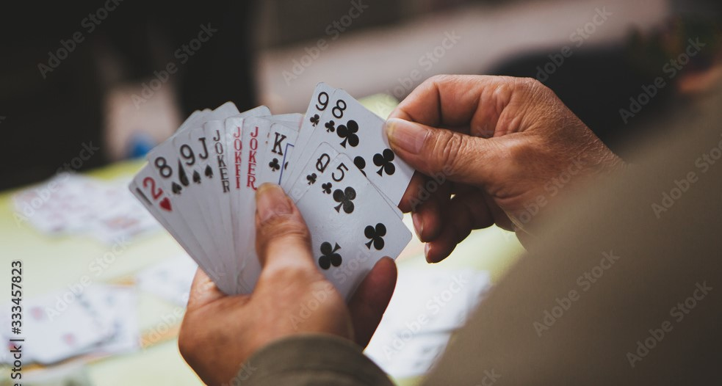

***“Bridge has the suspense of poker, the cerebral qualities of chess and the excitement of athletic sports-all in a social setting. It has been called the greatest card game of all time.”***

The class is geared for anyone, 12 years of age and up, who wants to start playing this exciting game. This is a hands-on interactive learning experience. No lengthy lectures or tons of homework - just fun and play. By the end of the class students will be invited to play in newcomer events as well.

**Tuesdays Sept. 17- Oct.22   
7-9 PM**

**Cincinnati Bridge Center  
2860 Cooper Road  
Cincinnati, Ohio 45241**

**$75 per student includes course materials and American Contract Bridge League membership.**

**Limited Enrollment!!! Register at cincybridge.com or for more information call 513-255-7240.**